Data Structures and Algorithms
LAB MANUAL



DEPARTMENT OF ELECTRICAL ENGINEERING,
FAST-NU, LAHORE

LAB1- Performance analysis

The Objective of this experiment is to study the analytical and experimental ways to evaluate the performance of different programs to analyze their efficiency in terms of execution time.

Introduction:
Performance Analysis of Algorithms and Data Structures
By performance analysis of a program, we mean the amount of memory and time required by it to run to completion. There are two methods to determine the performance of a program, one is analytical and the other is experimental.

Space Complexity of a program is the amount of memory it needs to run to completion.

Time Complexity of a program is the amount of computer time it needs to run to completion.

Analytical Analysis:
Analytically Finding time complexity of the following piece of code:

int sum,i,j;
sum = 0;
for (i=0;i<n;++i)
{ for (j=0;j<n;++j)
{ sum++;
}
}

Result:

Statement | Number of times executed
sum=0 | 1
i=0 | 1
i<n | n+1
++i | N
j=0 | N
j<n | n(n+1) = n² + n
++j | n²
sum++ | n²
Total | 3n²+4n+3
 | T(n) = 3n²+4n+3, T(n) = O(n²)

Exercise 1: For the following codes carry out the analytical analysis to evaluate time complexity and then express it in terms of Big O:

int sum,i;  sum = 0;  for (i=0;i<n;++i)  sum++;  Time complexity= 3n + 3  Big O= n | int sum,i,j;  sum = 0;  for (i=1;i<n;i=i*2)  sum++;  Time complexity= 3log2n + 3  Big O= log2n
int sum,i,j;  sum = 0;  for (i=0;i<n;++i)  {  for (j=0;j<n;++j)  { sum++;  }  }  Time complexity= 3n^2 + 4n + 3  Big O = n^2 | int sum,i,j;  sum = 0;  for (i=1;i<n;i=i*2)  {  for (j=0;j<n;++j)  { sum++;  }  }  Time complexity= 3nlog2n + 4log2n + 3  Big O= nlog2n

Experimental Analysis of Time of execution of Code.

To find time complexity of a code experimentally we need to calculate the time difference between starting and ending time of execution of code. So time.h library is needed for this purpose.

#include <iostream>
#include <time.h>
using namespace std;
void main()
{
clock_t start, end;
double cpu_time_used;

start = clock();
{ ... Code ...}

end = clock();
cpu_time_used = ((double) (end - start)) / CLOCKS_PER_SEC;
cout<<cpu_time_used;
}
Exercise2: Experimental Analysis

Execute the codes given in the table below and note the time of execution of each by setting the value of n=1000 to 10000000. Compare your results with the analytical results for the same codes in Exercise1.

int sum,i;  sum = 0;  for (i=0;i<n;++i)  sum++;  Tn=0,0.002,0.02 | int sum,i,j;  sum = 0;  for (i=1;i<n;i=i*2)  sum++;  Tn=0,0,0
int sum,i,j;  sum = 0;  for (i=0;i<n;++i)  {  for (j=0;j<n;++j)  { sum++;  }  }  Tn =19.727, | int sum,i,j;  sum = 0;  for (i=1;i<n;i=i*2)  {  for (j=0;j<n;++j)  { sum++;  }  }  Tn=0.004,0.039,0.466

Exercise 3:

Your task is to write a program that takes the following array of 10 numbers:

Input_Numbers [10]=[10000, 20000, 80000, 150000, 250000, 400000, 800000, 900000,1500000,200000]

Each number present in the Input_Numbers array above represents a value for n.

For the codes given for Exercise 1 and 2 note the execution time for each value of n given in the array above.
Then verify the asymptotic notation graph given below by plotting a separate graph, for each code, for time of execution vs n, for all the values of n given in the Input_numbers array.

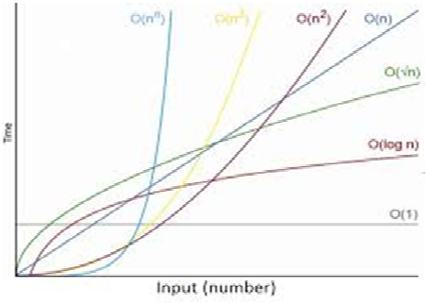

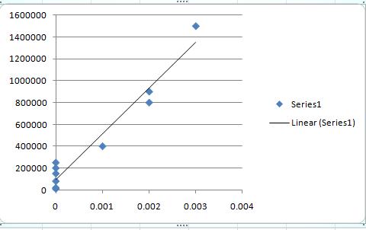

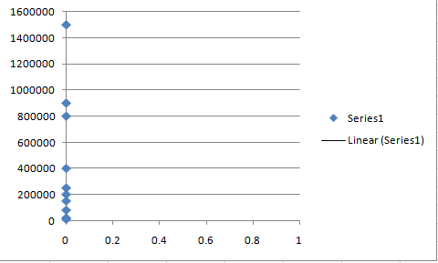

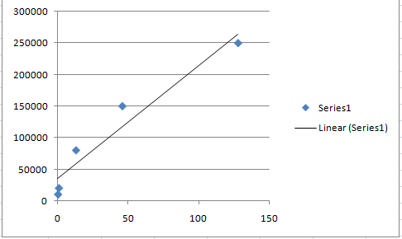
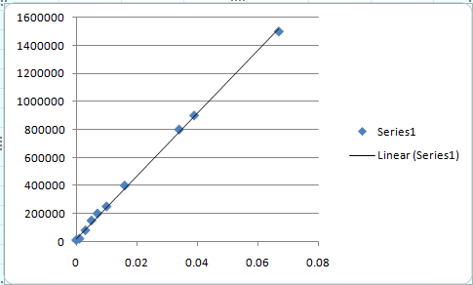
Exercise4:
Write a program to find the factorial of a given number
- iteratively

#include <iostream>
using namespace std;
void main()
{
int n,fact=1;
cout<<"ENTER THE NUMBER : "<<endl;
cin>>n;
for (int i=n;i>0;i--)
fact=i*fact;
cout<<"THE FACTORIAL OF THE NUMBER "<<n<<" IS "<<fact<<endl;
system("pause");
}

- recursively.

#include <iostream>
using namespace std;
int factorial(int n)
{
if(n<=1)
return 1;
else
return n*factorial(n-1);
}
void main()
{
int n,fact=1;
cout<<"ENTER THE NUMBER : "<<endl;
cin>>n;

cout<<"THE FACTORIAL OF THE NUMBER "<<n<<" IS "<<factorial(n)<<endl;
system("pause");
}

Tell the difference in terms of time and space complexity.

POST Lab:
Following is a sorting algorithm. Your task is to run the code. Find the execution time. And by looking at execution time Find he Big O. Also tell which type of code is this, Iterative, recursive, infinite loop, linear?

